OpsCenter Ver 7.5.0.3
(No data in reports error fixed summary)

Phase 1

Froze the cluster and stopped Ops center.

Backed up database
D:\program files\symantec\opscenter\bin> dbbackup

Backed up the opscenterserversrv.xml file

Changed "-Xmx " from 4096M to 6144M (from 4GB to 6GB) in opscenterserversrv.xml file

Simplified the database server startup and corrected a type (of the extra -m)
File: Server_db_conf_server.conf

From

-n Opscenter_usclusrpt01 -x tcpip(LocalOnly=YES;ServerPort=13786) -gd DBA -gk DBA -gl DBA –gp
4096 -ti 0 -c 8G -ch 20G -cl 4G -zl -os 1M -m -o
"D;\Program Files\symantec\Opscenter\server\db\log\server.log" -m

To

-n Opscenter_usclusrpt01 -x tcpip(LocalOnly=YES;ServerPort=13786) -gd DBA -gk DBA -gl DBA -gp
4096 -ti 0 -c 20G -cs -os 1M -m -o
"D;\Program Files\symantec\Opscenter\server\db\log\server.log"

Increased Database memory from 8GB to 20GB (Total physical Memory 32GB)
2GB for GUI

Phase 2

Removed VMware access hosts name usvhildcms02 from master server
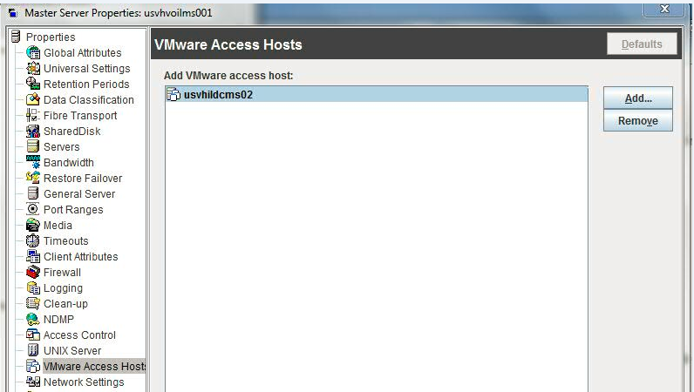

Increased client timeout from 10 mins to 1 hour,
by adding below line in /opt/SYMCOpsCenter/config
Nbu.scl.requestTimeoutlnMillis=3600000
Opscenter\Server\config\scl.conf

Restarted Opscenter
D:\program files\symantec\opscenter\bin> Opsadmin stop
D:\program files\symantec\opscenter\bin> Opsadmin start

Opscenter web GUI
Settings configuration usvhvoilms001 Data Collection Disable
Data Collection Enable

Currently working on replicate the same settings over to the configuration on the inactive node “usnjnbrpt01”
After that I will unfreeze the cluster.

Phase 3

Appliance Hardware Data collection Error ---fixed

After reviewing logs from master server and Opscenter, data collection on appliance hardware is failing because an invalid appliance hostname “nb-appliance” was added in the appliance media server list
-------------------------------------------------------------------
$ nbemmcmd -listhosts
NBEMMCMD, Version:7.1
The following hosts were found:

media nb-appliance
---------------------------------------------------------------------

$ vmoprcmd -devmon hs | grep nb-appliance

HOST STATUS
Host Name Version Host Status
========================================= ======= ===========
nb-appliance 710700 DEACTIVATED
----------------------------------------------------------------------

We try deactivating but still opscenter trying to get hardware information from master server for the appliance media server “nb-appliance”

After confirming from Mila/Cleveland
I deleted the media sever hostname “nb-appliance” with command

nbemmcmd –deletehost –machinename nb-appliance –machinetype media

After deleting, Data collection on appliance hardware is success.

