Backup Exec v12 Windows Server 2008 Cluster Installation.
Install Backup Exec on each node.
Add Failover Clustering Feature from Windows 2008 Server Manager.
You can use a file share as a quorum when setting up a Windows 2008 cluster but you still need a shared disk to cluster Backup Exec.
Add the shared disk using Failover Cluster Management.
Go to the active node (you should see the shared disk as a local drive).
Run the Cluster Wizard from Backup Exec console.

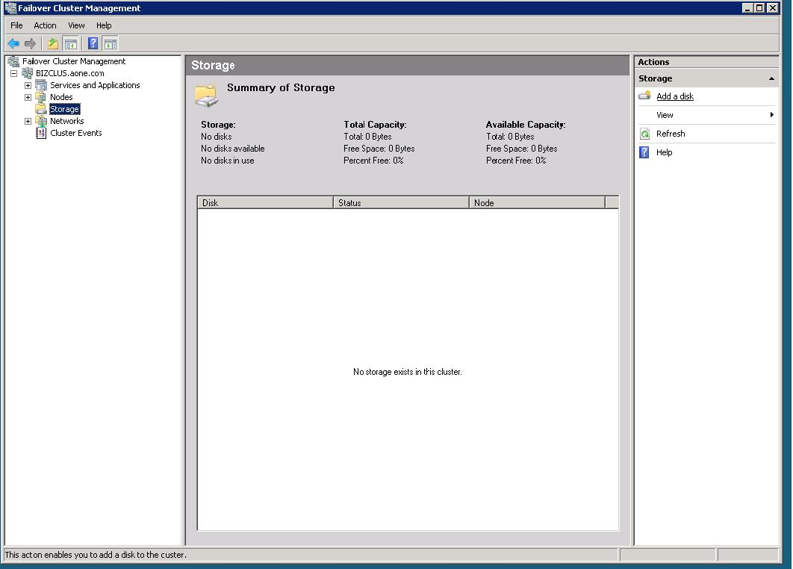
Failover Cluster Managerment
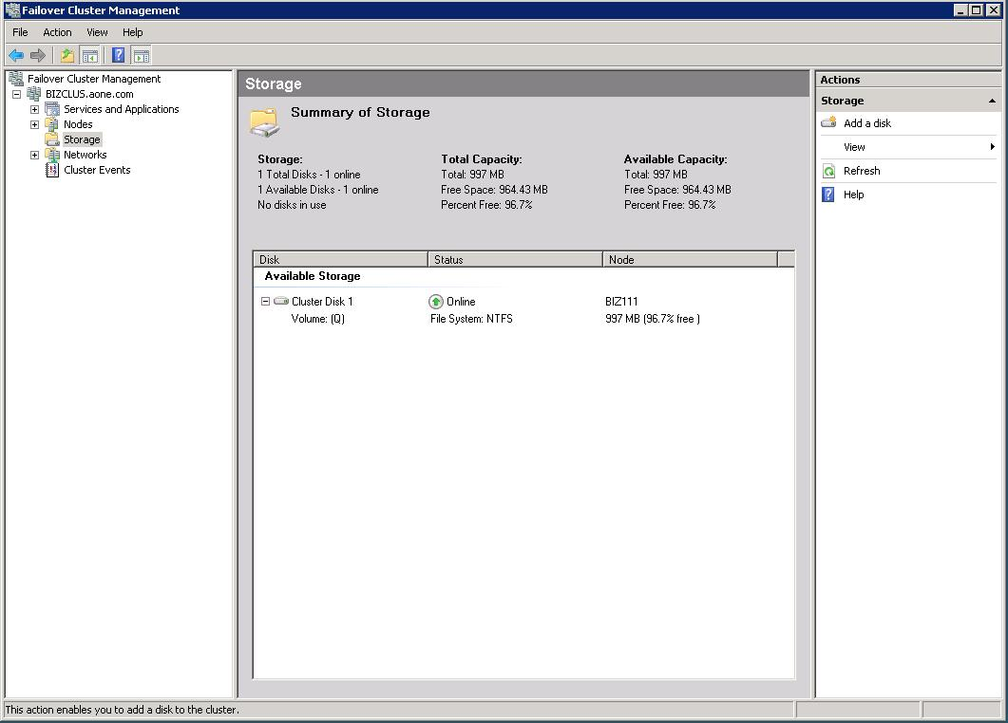
Add a Shared disk to cluster.

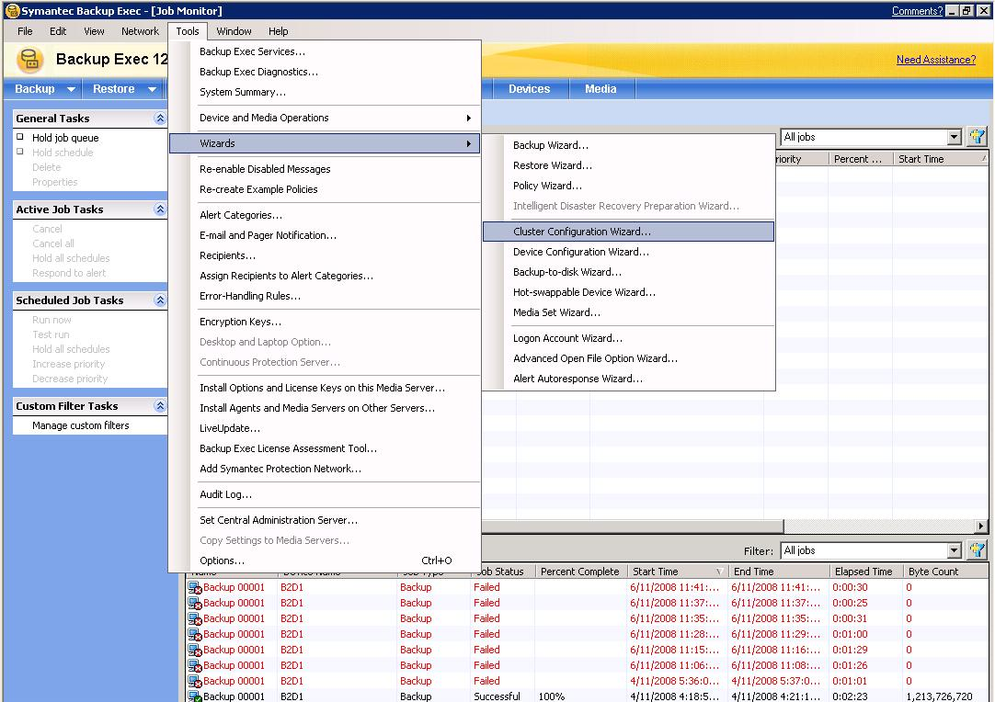

Run Backup Exec Cluster Wizard on the node where the shared disk is online.

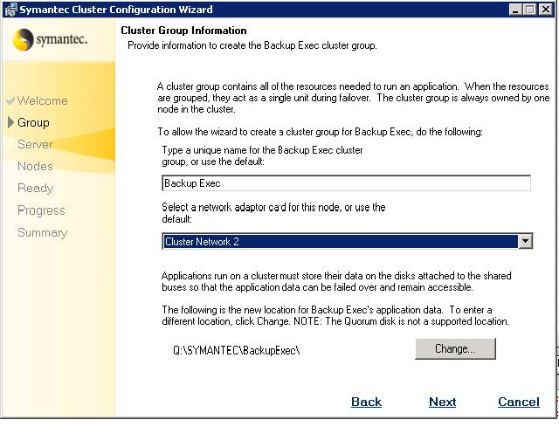

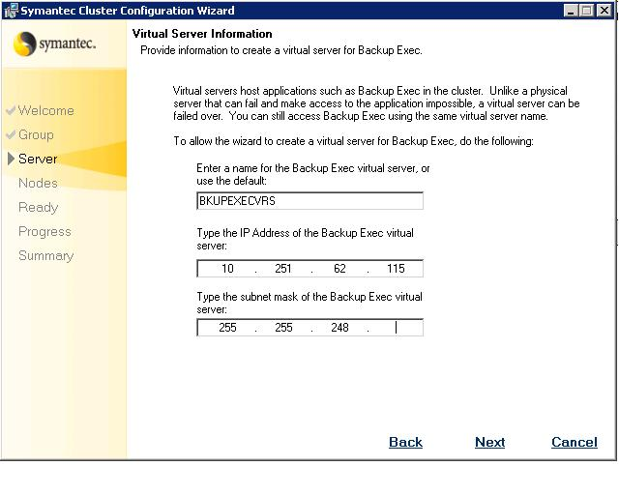
Type the IP address of the Backup Exec Server.

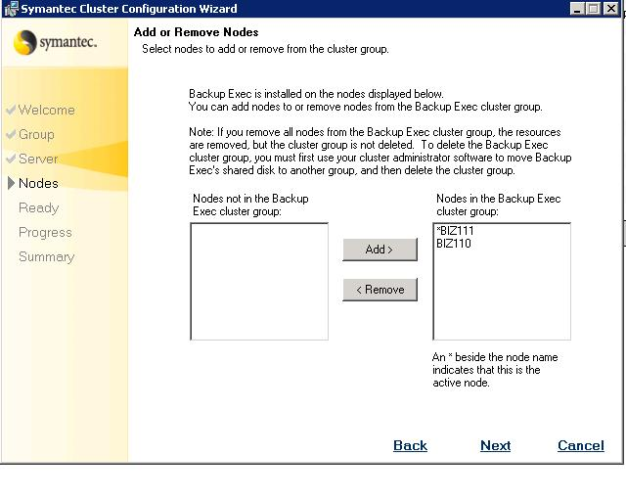
Add the Backup Exec nodes.

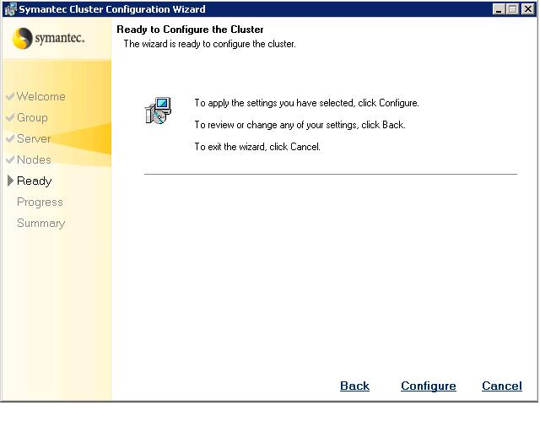

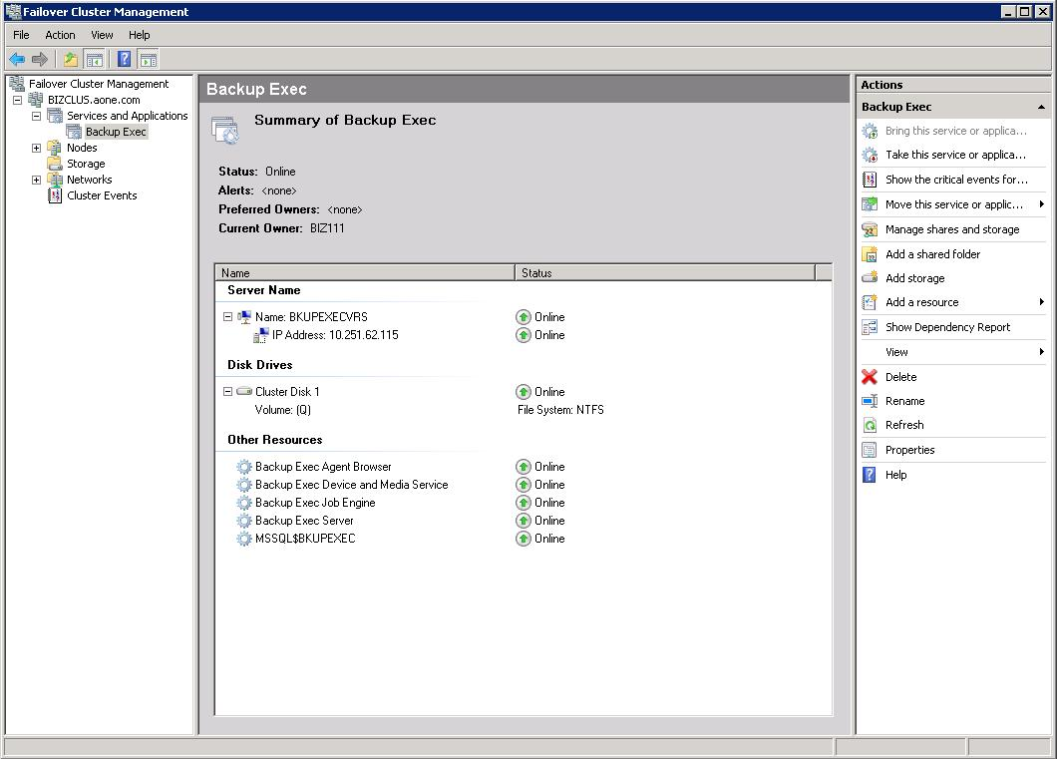

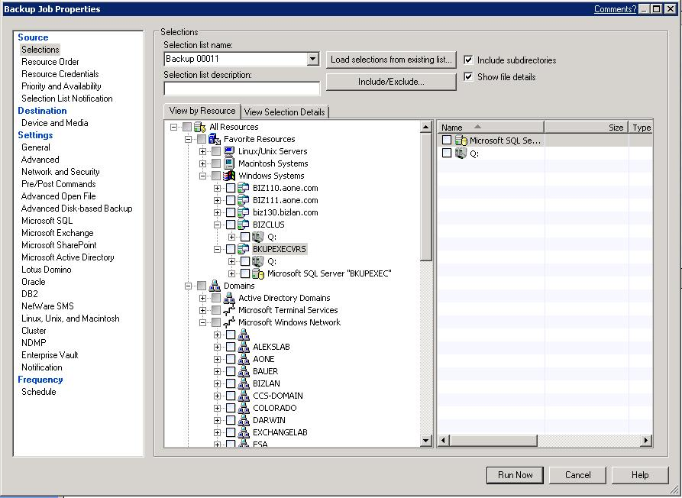

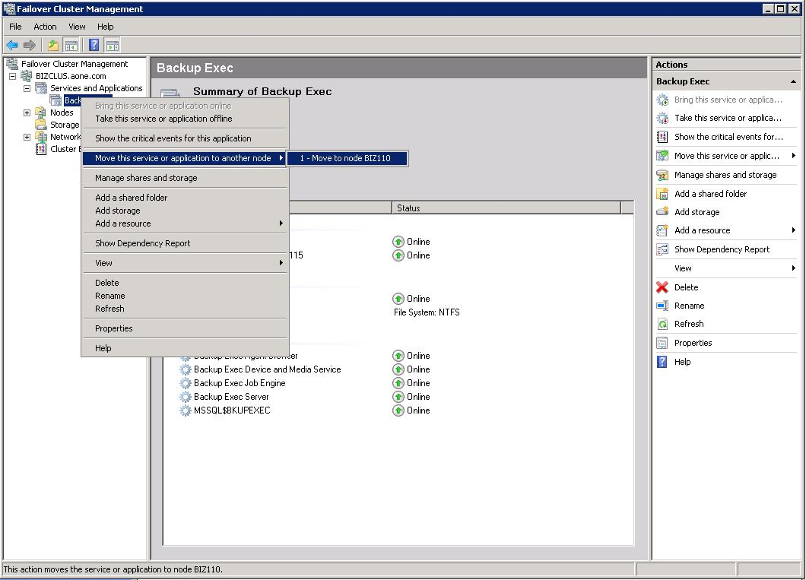

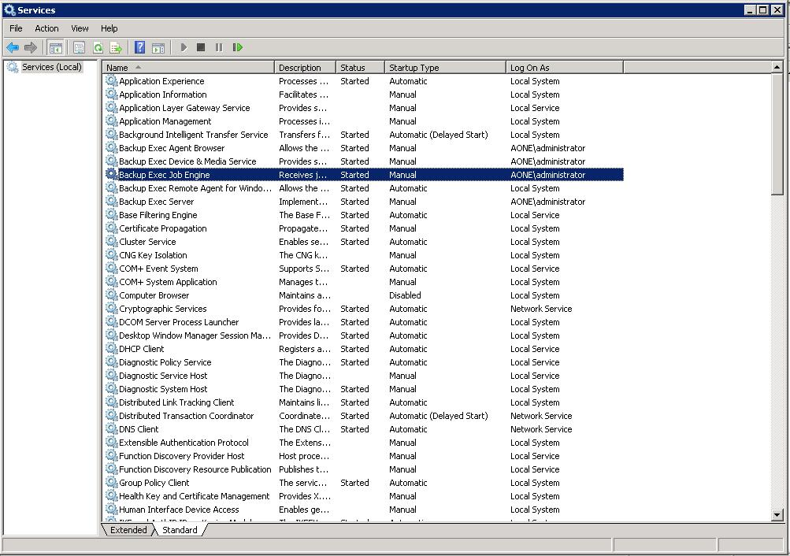

All Backup Exec services, except RAWS are set to manual.
Always use Failover Cluster Management to stop or start Backup Exec services.

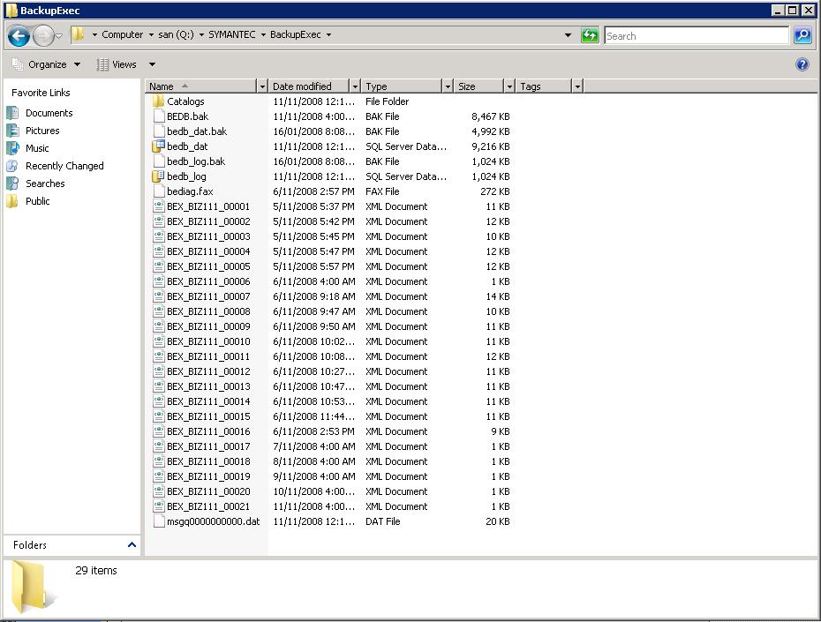

The Backup Exec shared folder on the shared disk.

