NetBackup Self Service User Guide
Version 9.0

Contents
My Assets (Homepage) – Overview 3
Dashboard – Overview 3
Usage - Overview 4
My Assets 5
Finding Assets 5
Search 5
Filter 5
Protection Status 5
Sorting 6
Asset Type 6
Consumed Capacity Charts 6
Asset Detail Page 7
Asset Dashboard Tiles (Virtual Machine tab) 7
Consumed Capacity 7
Protection Status 7
Last Backup Date/Time 7
Consumed Capacity Charts 7
Viewing Backups (Backup tab) 8
View backup list 8
Expire backup images 8
Backup and Restore Actions 9
Add Protection 9
Remove Protection 10
Ad Hoc Backup (Backup Now) 10
Agent Based File Restore 11
Agentless File Restore 11
Restore VM / Disks 12
Restore SQL (and Oracle) 12
FAQs 13
Q: I cannot see an expected backup image listed within my asset. 13
Q: Why can’t I see my computer is protected? 13
Q: Within NSS, can I change the language preference? 13
Q: What are Protection Types and Levels? 14
Q: How does Protection Status work? 14
Q: What is Consumed Capacity? 14

My Assets (Homepage) – Overview
Current Consumed Backup Space –click to view details

Protection Status Counts “Traffic Lights” – click to filter assets – each asset has a status of Attention, Unprotected, or Protected

Consumption Trend – 6 month new / average / end total – click to view usage by asset

Asset list – click on the name to view “Asset Detail” and access backup / restore actions. Assets can be protected by one or more protection levels.

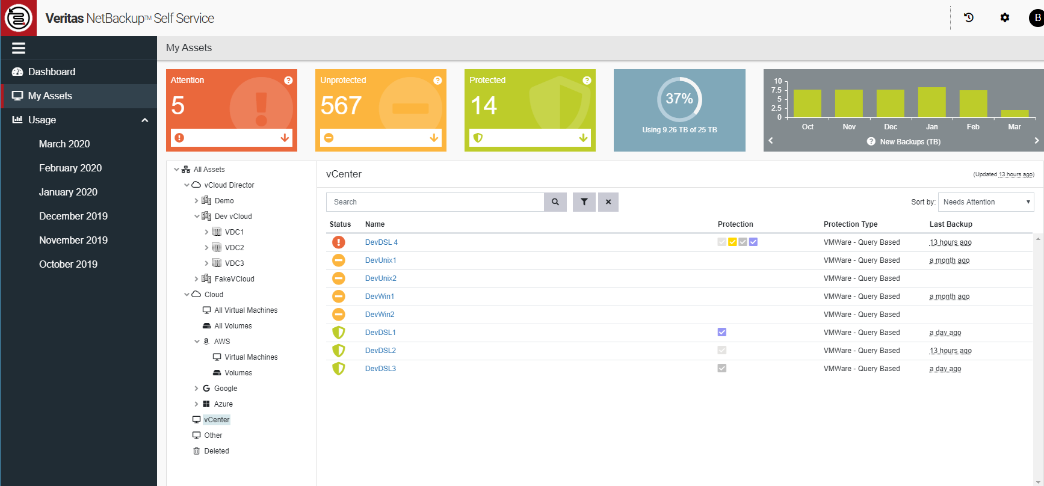
Asset tree list – click to explore / filter asset list to right – green ticks indicate container level protection.

Dashboard – Overview
Assets with the largest total backup image size
Assets which are protected, unprotected, and protected but backup has failed
Totals for number of assets, number of backups and total size of backups in the system

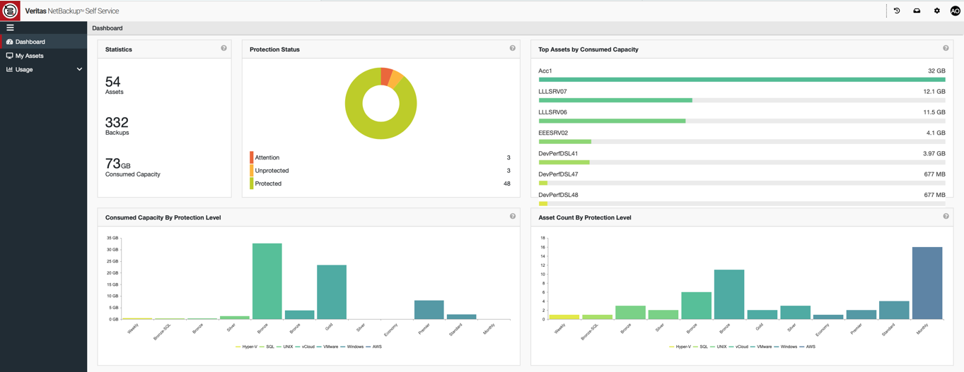

These charts show chosen attribute grouped by protection level. To filter you can click on the labels at the bottom of the chart.

Usage - Overview
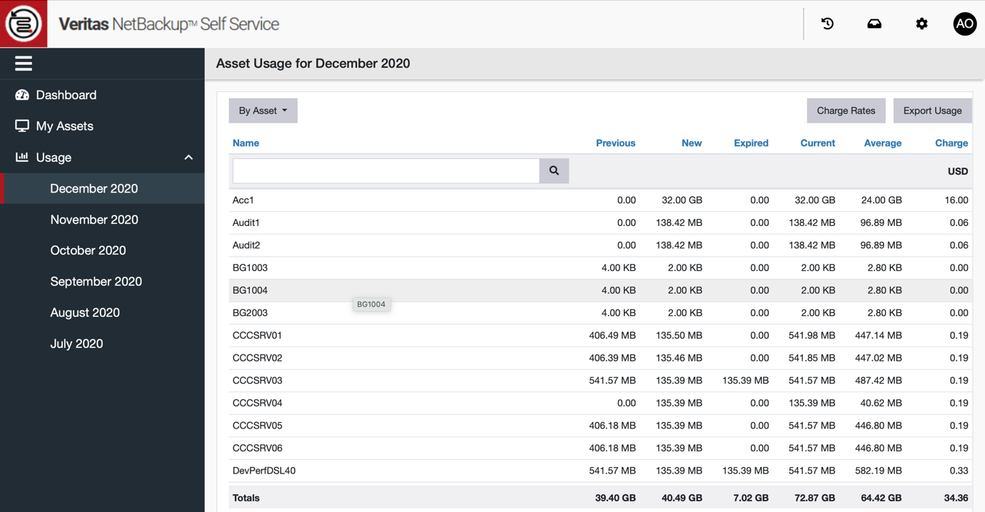
‘Current’ cc (consumed capacity) = <Previous cc>+<New cc>-<Expired cc>

Average consumed capacity for the month
Choose month to analyse

Monthly Charge <optional>

My Assets

Finding Assets

Search
Start typing in the search box to immediately search the asset the asset list.
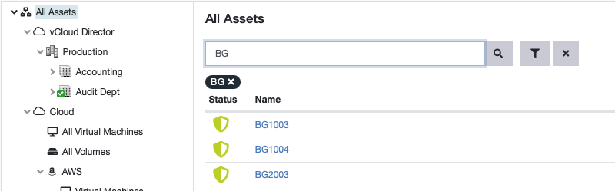

Filter
Click on the filter icon to select a Protection Status and / or Type filter.
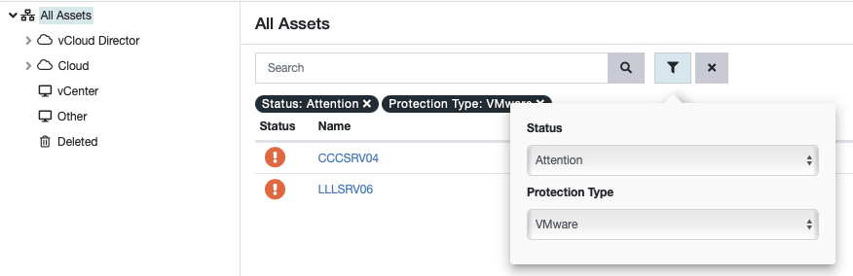

Protection Status
Click on the Protection Status coloured tiles (“traffic lights”) to immediately filter the assets.
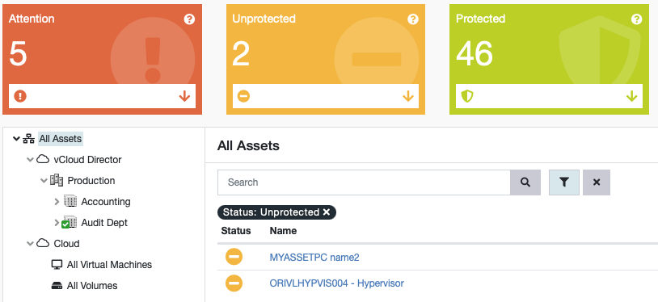
See more on Protection Status here.

Sorting
The Sort By drop list controls the sort order of the current Asset List.
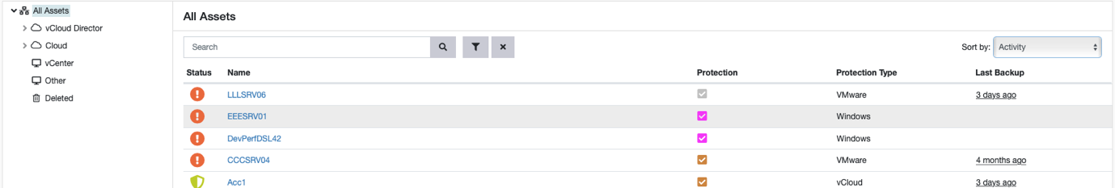

Asset Type
The tree list to the left of the page displays all assets grouped by type and / or discovery method by Self Service. Selecting a node in the tree immediately filters the Asset List.
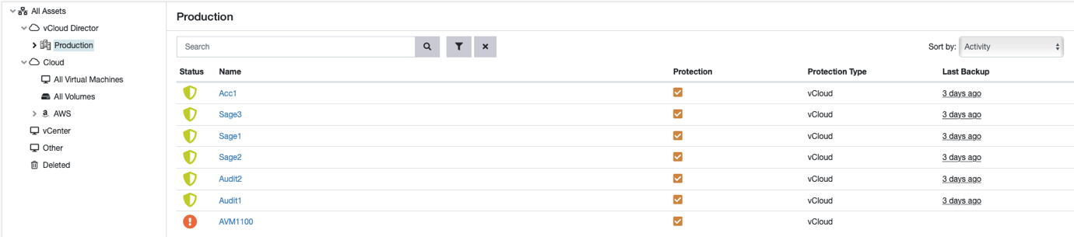

Consumed Capacity Charts
New Backups - Shows the total size of new backup images in each monthly period (Front End)
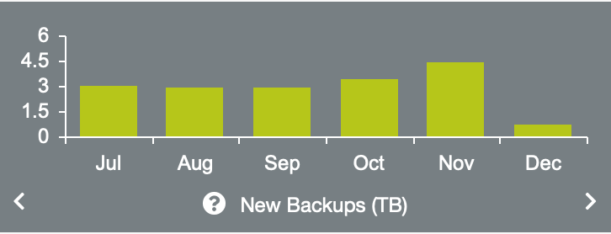
Total Consumed Capacity – Shows the total size of all backup images at the end of each monthly period (Front End)
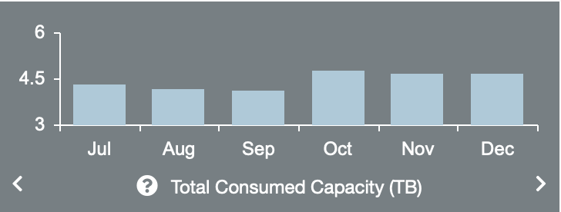
Average Consumed Capacity - Shows the total size of all backup images, averaged over a monthly period (Front End)
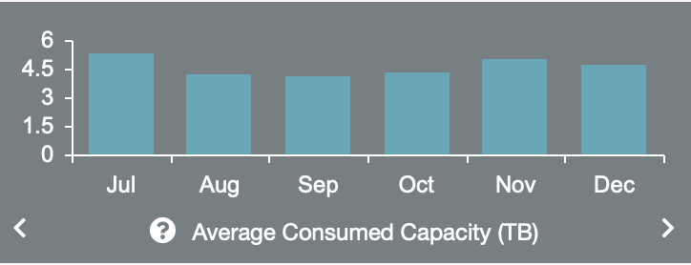

Asset Detail Page
Clicking on an asset name in the list selects it and loads the Asset Detail page. More details of the asset are visible here including access to all possible actions.
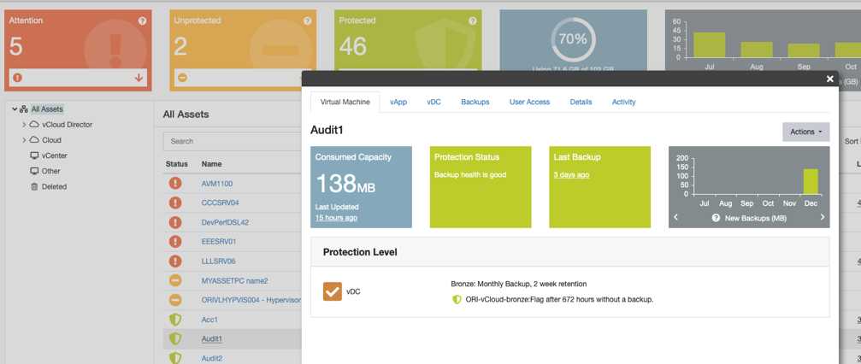

Asset Dashboard Tiles (Virtual Machine tab)
The tiles visible on the first tab show:

Consumed Capacity
The current total consumed capacity of all the backups associated with the asset. This is “front end” or original size of backup. For example, if a 100MB VM has 2 full unexpired backups this number would be 200MB.

Protection Status
As with the homepage dashboard this show Attention (red), Unprotected (amber) or Protected with backups present with allotted SLA (green). Read more about Protection Status.

Last Backup Date/Time
The most recently detected backup for the asset.

Consumed Capacity Charts
Three bar charts covering the last six months for the asset. These use the same attributes as the tenant level Consumed Capacity Charts detailed above but for a single machine.

Viewing Backups (Backup tab)

View backup list
Click on the ‘Backups’ tab to view a list of backups. All backups will be shown including those managed outside of NSS.
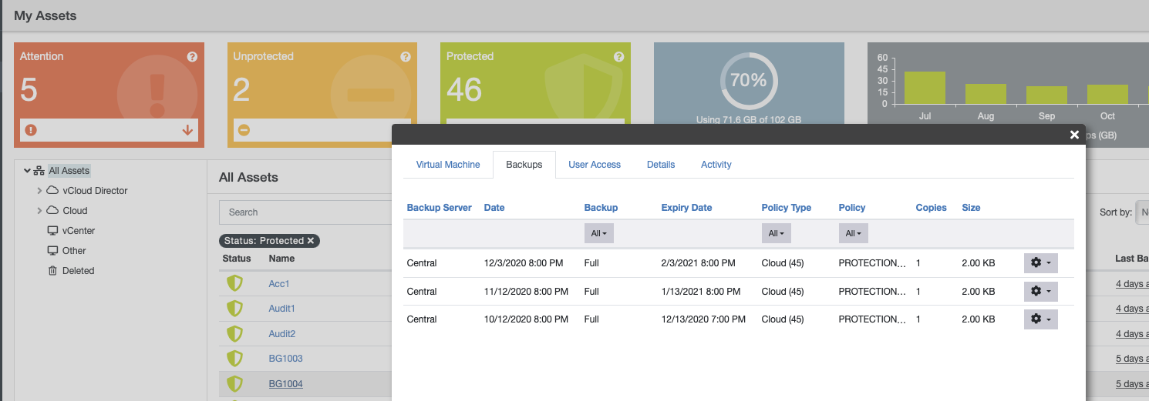

Expire backup images
To expire a backup, click on the cog on the right and select ‘Expire Backup’
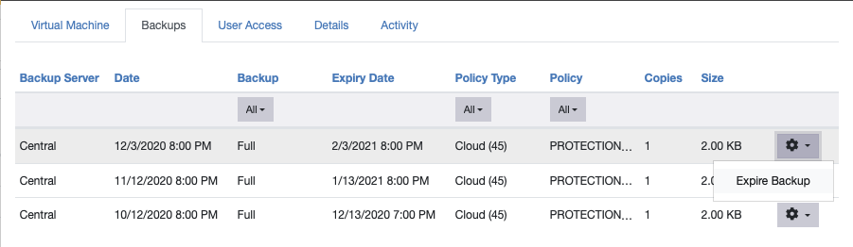

Backup and Restore Actions
To run backup and restore actions, click the ‘Actions’ Button and select the relevant operation.
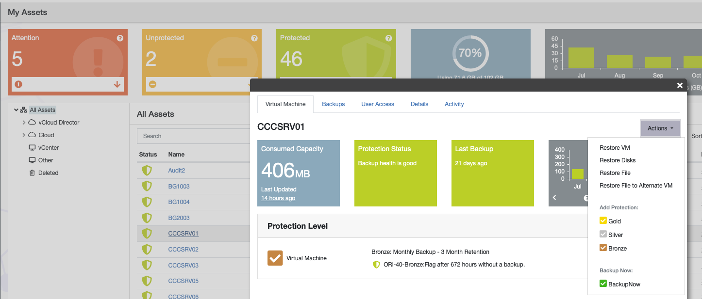

Add Protection
Select from available Protection Levels (in this example called Gold, Silver and Bronze) to apply to the machine. Hover with mouse over each Protection Level to reveal more details on each option.
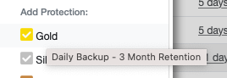
Each Protection Level has NetBackup policy attributes for backup frequency, backup time, retention level etc. After checking the details, click ‘Protect’ to add the machine to a policy in NetBackup.
The machine will be added to a policy in NetBackup with the naming convention
<Tenant Name>-<Protection Type Code>-<Protection Level>
If this policy already exists in NetBackup, the machine will be added to it. If the policy does not exist it will be created in NetBackup.
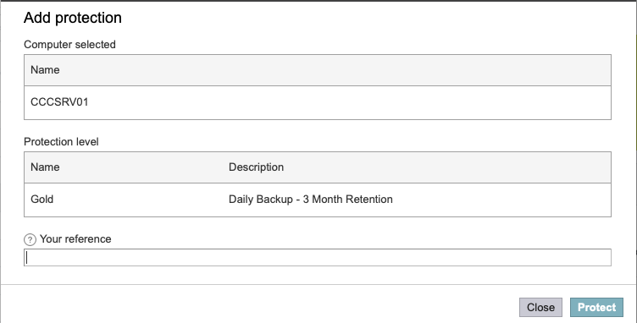

Remove Protection
Select Remove Protection from the Asset detail page.
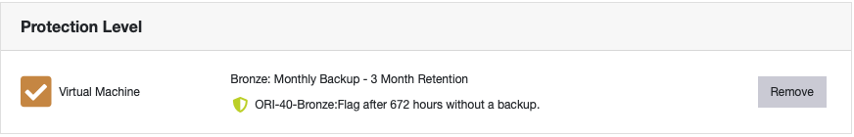
After checking the details, click ‘Unprotect’ to remove the machine from the associated Protection Level.
If this is the only machine in the policy the now empty policy is automatically deleted
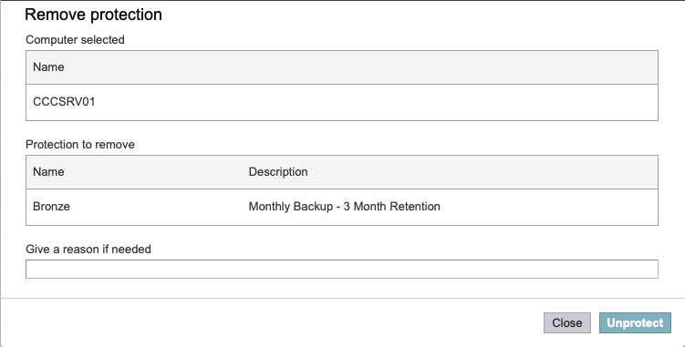

Ad Hoc Backup (Backup Now)
Select from available Backup Now options (in this example called Premier and Economy) to apply to the machine. Hover with mouse over each Protection Level to reveal more details on each option.
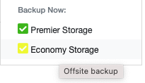
After checking the details and selecting a retention period, click ‘Protect’ to make an immediate backup image in NetBackup.
NSS manages creating and running the temporary backup policy in NetBackup. After completing the backup, the temporary backup policy is deleted.
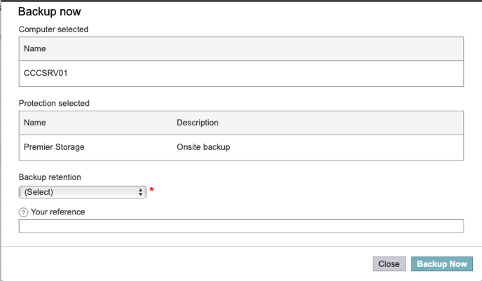

Agent Based File Restore
‘Restore File’ from restore options will automatically be available when a NetBackup agent has been deployed to a target machine.
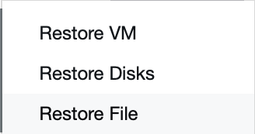
After checking the details and selecting a backup and the associated files/folders to restore, click ‘Restore File’ to instruct NetBackup to restore the chosen files/folders.
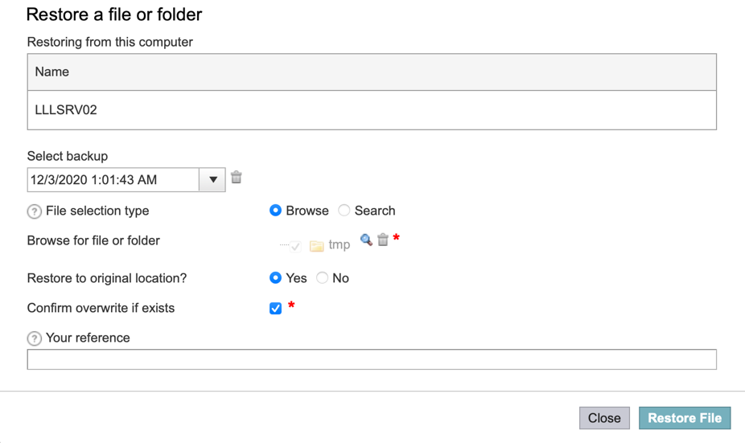

Agentless File Restore
‘Restore File’ and ‘Restore File to Alternate VM’ from restore options will automatically be available when a NetBackup Master Server supports VMware agentless file restore.
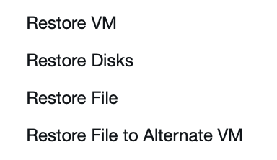
Target machine name and associated credentials are required. After checking the details and selecting a backup and the associated files/folders to restore, click ‘Restore File’ to instruct NetBackup to restore the chosen files/folders.
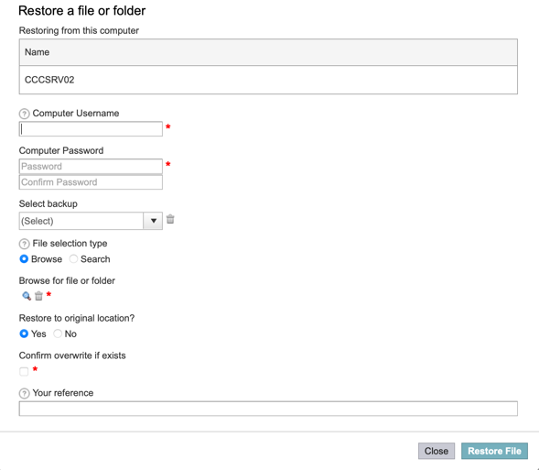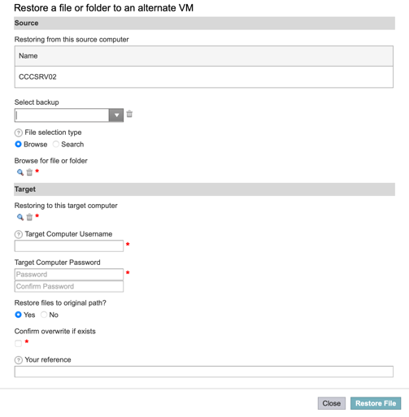

Restore VM / Disks
Select from available Restore options. ‘Restore VM’ actions a whole machine restore. ‘Restore Disks’ can be used an alternative to ‘Restore VM’, this In-Place Disk Restore action lets you restore all disks without altering attributes such as the MoRefId.
After checking the details and selecting a computer to restore, click ‘Restore VM’ or ‘Restore Disks’ to instruct NetBackup to restore the chosen machine/disks.
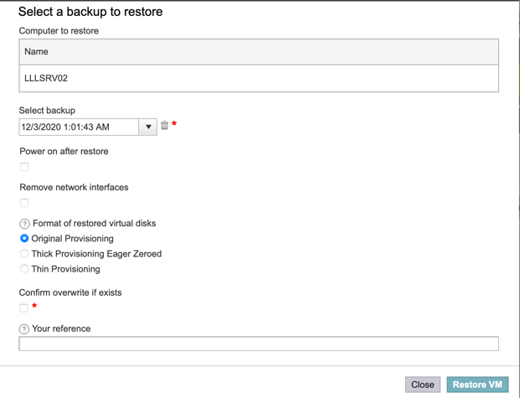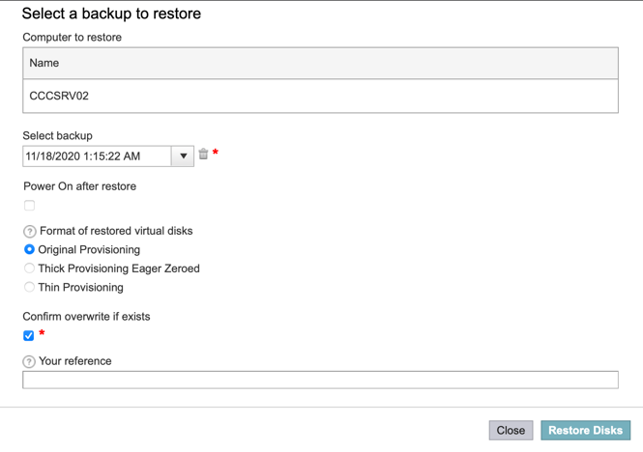

Restore SQL (and Oracle)
Where a Microsoft SQL Server (or Oracle Database) backup is available the relevant option to restore will be available (in this case below for Microsoft SQL Server).
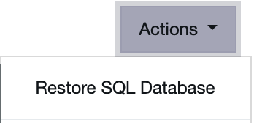
After checking the details and selecting a database to restore, click ‘Restore SQL Database’ to send a request to the specified Database Administrator with instructions to carry out the restoration .
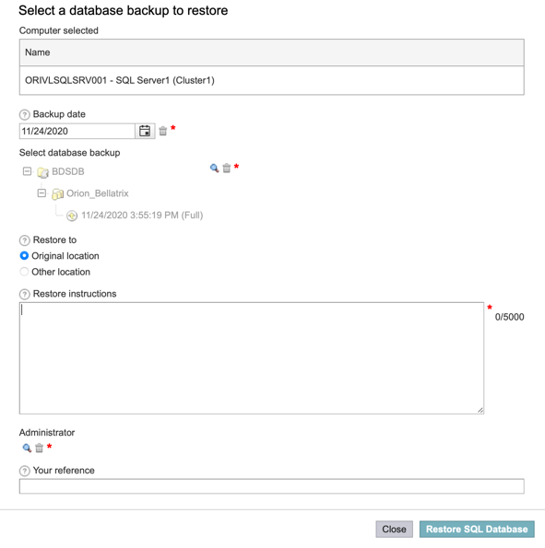

FAQs
Q: I cannot see an asset I expect to see in my asset list?
A: First check if you have any filters or search criteria set on your asset list that might be limiting the results. If you have no filters/search applied, check with your local tenant administrator if they need to add you to the list of allowed users to view the asset.

Q: I cannot see an expected protection option?
A: The options you see against an asset are determined by how the asset was registered in NSS. Contact the system administrator to check that the expected option/s are configured for your asset and/or tenant.

Q: I cannot see an expected restore option?
A: Restore options will only ever be displayed if there are valid, unexpired images available for the asset on the Backup Server. Does your asset have images in its Backups list? Some restore options are dependent on the configuration of the registered asset in NSS. If your asset has valid images, check with your system administrator that it is set up to allow restore operations.

Q: I cannot see an expected backup image listed within my asset?
A: Images are mapped to NSS assets every night during a System Sync. If the image was generated by a scheduled NetBackup policy after the last sync, it will not be visible in the system until after the next sync. You can however request that a system administrator syncs the backups for a single asset if necessary, or even to manually start the full System Sync for all assets.

Q: Why can’t I see my computer is protected?
A: After adding your machine into a Protection level, the Status will appear Red until the scheduled policy has run in NetBackup. This will normally update (and go Green) the next day.

Q: Within NSS, can I change the language preference?
A: Out of the box NSS supports the following languages: English (US), French, German, Simplified Chinese and Japanese, and a customer can choose to install Self Service in any one of these languages.
If you operate a user base across multiple countries, you can enable some or all of the other support languages from the list above within the one portal.
A system administrator can enable a language via Admin->Settings->Currency & Language->Language and 'enable' the chosen language
A user can change their language via clicking on the chevron at the top right of the homepage by their name and selecting My Account->Language, English (UK) will now appear as an option.
As an NSS or Tenant admin, can also set a user's default language can be set via Admin->Organization->User and select the user and update their preferred language.

Q: What are Protection Types and Levels?
A: A ‘Protection Type’ defines all the backup services available for a workload.
As a general rule there is a ‘Protection Type’ for each workload supported and typically these would be named as follows.
- VMware
- Windows
- SQL
- Unix
Within each ‘Protection Type’, ‘Protection Levels’ are defined. Each ‘Protection Level’ has a set of backup attributes (backup retention, backup frequency, etc) defined in a template which is used to define each NetBackup Backup Policy created by NSS when a Protection Level is applied to a machine.
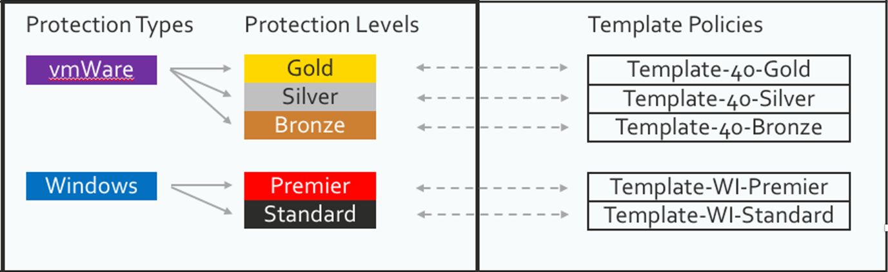

Q: How does Protection Status work?
A: Against each ‘Protection Level’ above you can define a ‘threshold’ in hours. Evaluating the thresholds of all the known policies that a computer is in determines its red, amber, or green status.
- Red Protection level applied, and all policies have backups within their threshold
- Amber No protection level has been applied to the computer (‘managed’ only)
- Green Protection level applied, but one or more policies have no backups, or the most recent backup is outside of its threshold
Computers that are protected with only a ‘Backup Now’ process are not included in the count and are not shown as protected.

Q: What is Consumed Capacity?
A: NSS reports against both 'Total Consumed Capacity' (total front-end size of all backup images at the end of each monthly period) and 'Average Consumed Capacity' (total front-end size of all backup images, averaged over a monthly period).
Below is an example to show you what NSS reports.
A: If you have a 100GB VM and you run a VMWare full backup with accelerator, assuming that the VM is 50% full, NSS will report 50GB as protected space and 50GB of data will be transferred to the storage medium (the first time the policy runs). The next day the transferred data will drop by as much as 99% but NSS will still report the protected space as 50GB (or very near to that number unless huge changes have taken place) as the backup image supports a full VM restore.
To clarify there are two viewpoints for charging:
Scenario 1. From Veritas to the NSS Customer
This is FETB where you take the largest Image and refers to “data under protection” and ignores extra stored copies retention etc.
https://www.veritas.com/support/en_US/article.000112039
Scenario 2. From the NSS Customer to their Customers/Departments
This is as above but off course now addresses the copies, retention etc. as this is all about BaaS and is what is shown in NSS.
NSS displays Scenario 2.
NetBackup deals with Scenario 1.

Q: Where can I get more information on NSS?
A: More information on NSS can be found on VOX (Veritas Open eXchange) Click here to goto Vox or go to https://vox.veritas.com/t5/NetBackup-Self-Service/bd-p/NetBackupSelfService

