NetBackup AIR (Automatic Image Replication) Configuration
Make sure you have configured your Storage server for MSDP on both sites.
1. Open your storage server on your Primary (OC) site.
“Media and Device Management” -> “Credentials” -> “Storage Servers” and click on “Replication” tab.
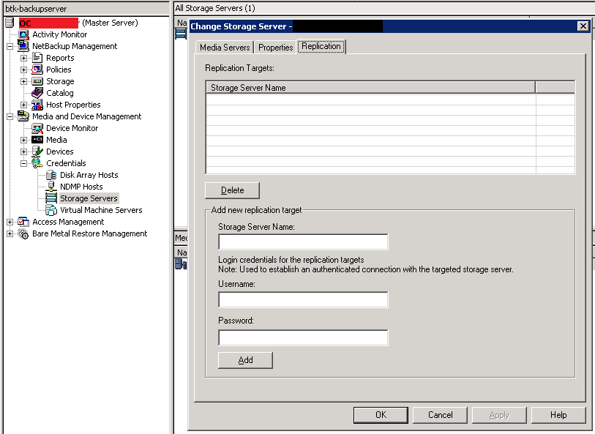
2. Add your DR (Secondary) site storage server (with MSDP credentials).
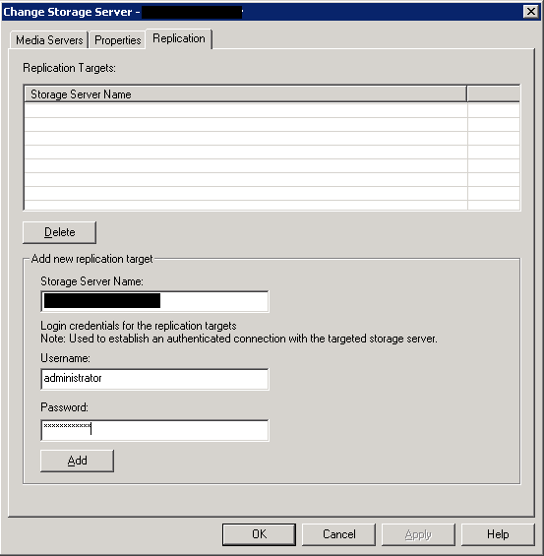
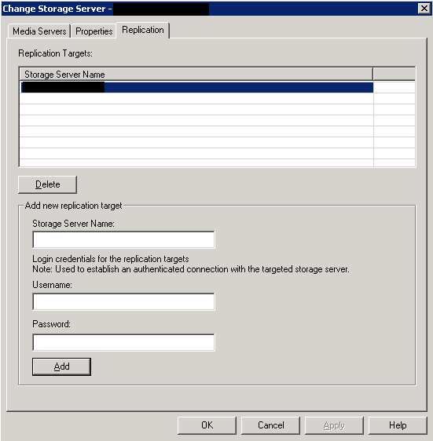
Create your Disk Pool on your OC site:
“Media and Device Management” ->”Devices” -> “Disk Pools” -> New
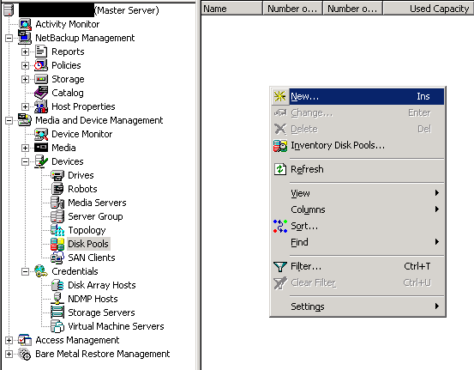
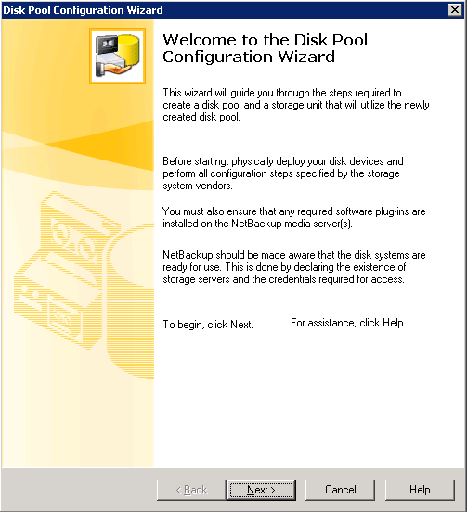
Select Puredisk as “Disk Pool Type” and select your OC site storage server
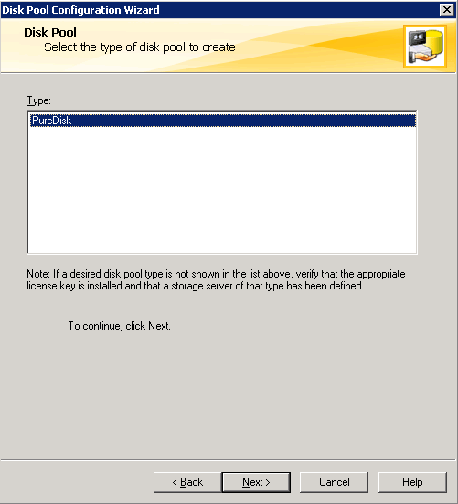
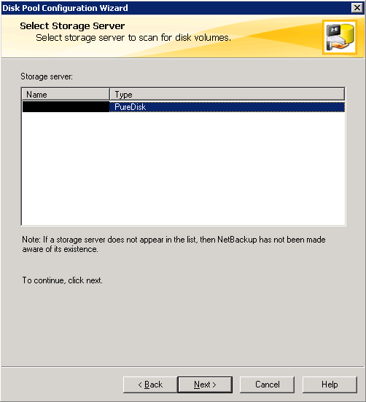
Select Puredisk as “Disk Pool Type” and select your OC site storage server
Select the Volume you have on your OC site storage server
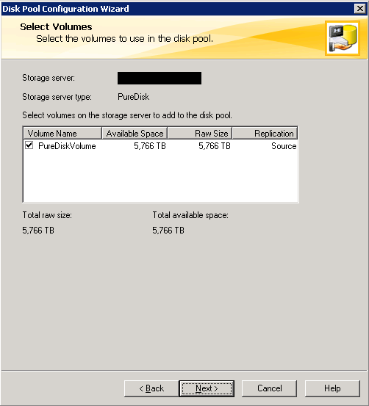
Fill your new disk pool properties and verify them and click Next and then Click Next to start Creating your Storage Unit.
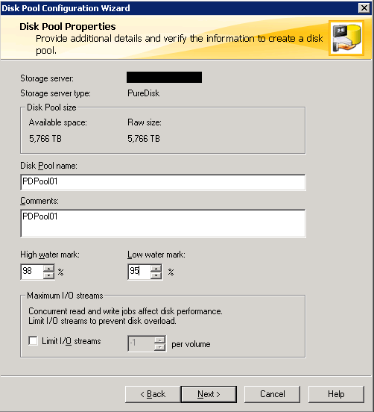
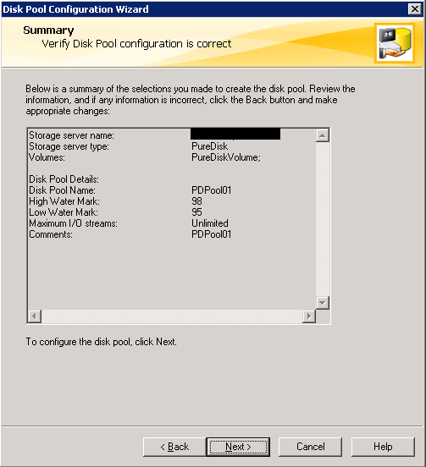
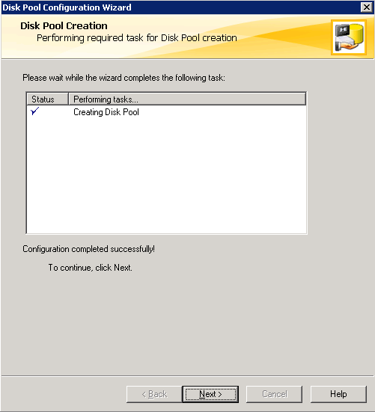
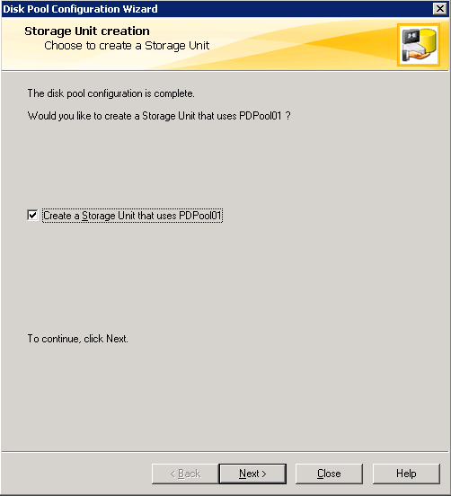
Fill your new Storage Unit properties and then click Finish.
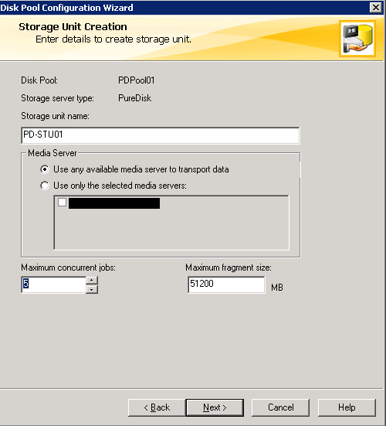
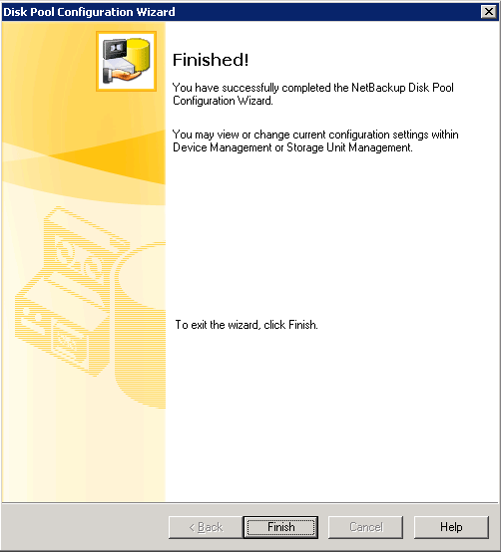
Connect to your DR site master server and create a new disk pool.
“Media and Device Management” ->”Devices” -> “Disk Pools” -> New
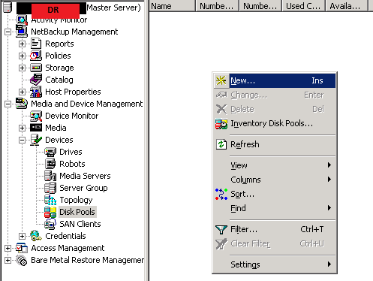
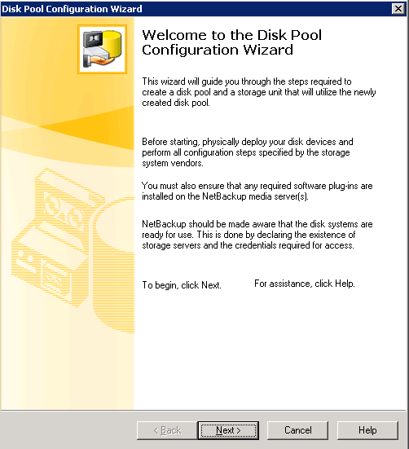
Select Puredisk as “Disk Pool Type” and select your DR site storage server
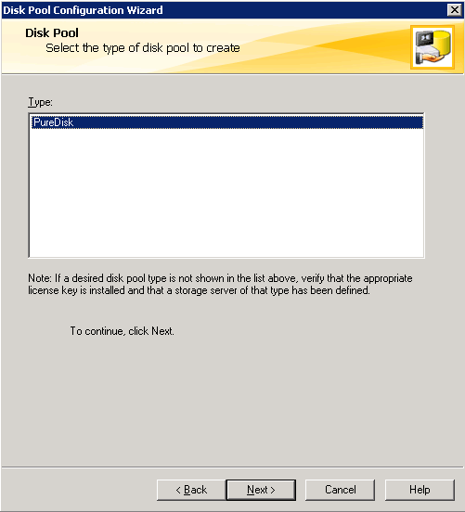
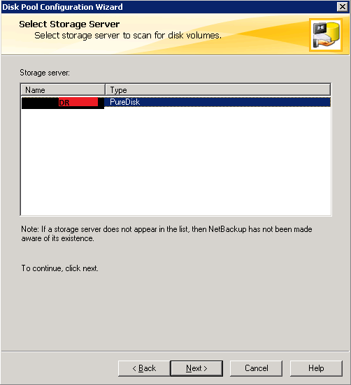
Select the Volume you have on your DR site storage server, note that the “Replication” column is now “Destination”
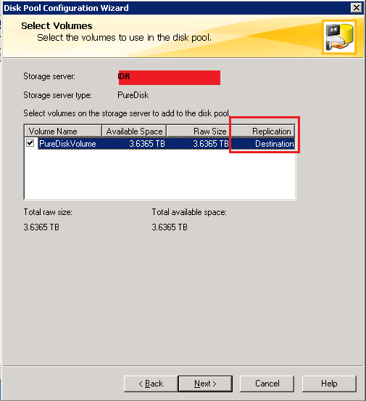
Fill your new disk pool properties and verify them and click Next and then Click Next to start Creating your Storage Unit
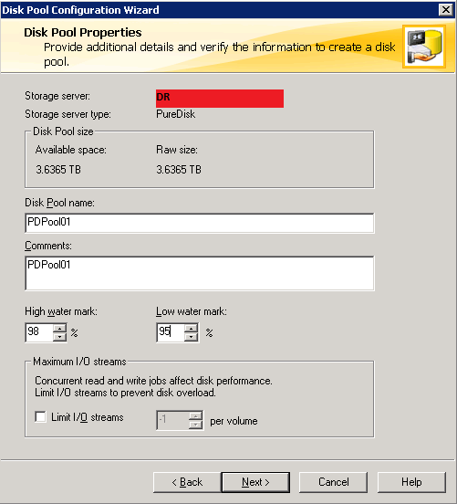
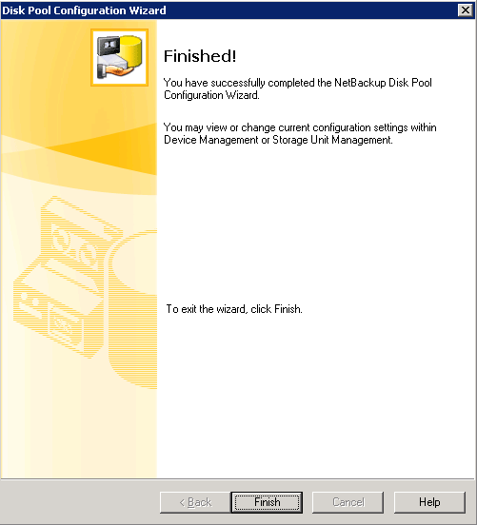
5)On your OC site master server, go to “NetBackup Management” -> “Storage” -> “Storage Lifecycle Policies” -> New
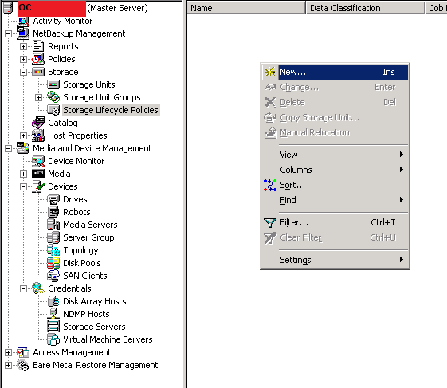
Click “Add” and create a “New Storage Destination”. Note that Automatic Image Replication is only possible when you first backup to an OST device/server (like Puredisk in this example). So PD-STU01 should be selected as the first backup point.
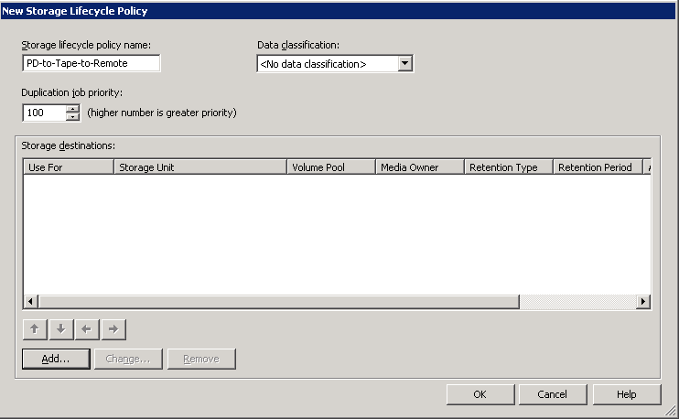
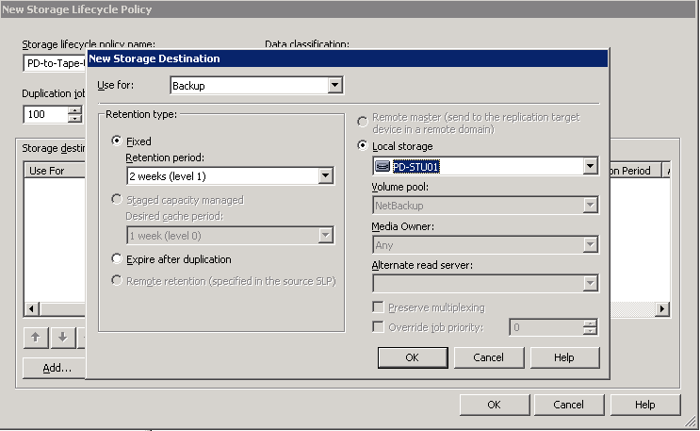
If you have other storage units, you can add them as well. In this example a tape device is added. Then using the right arrow, make this a copy of the first.
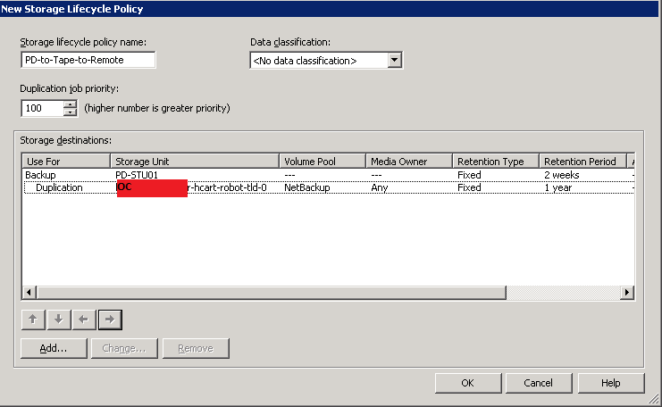
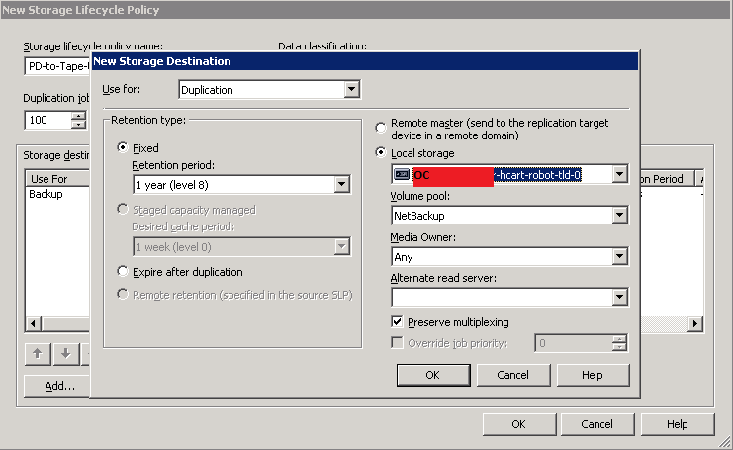
Click “Add” once again and choose “Remote Master” as the destination of this copy and make sure it’s place by using the arrows.
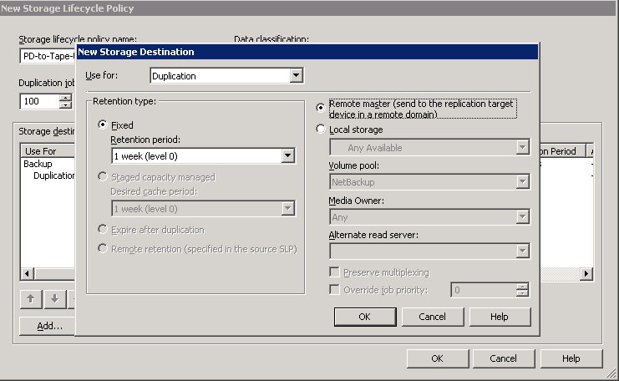
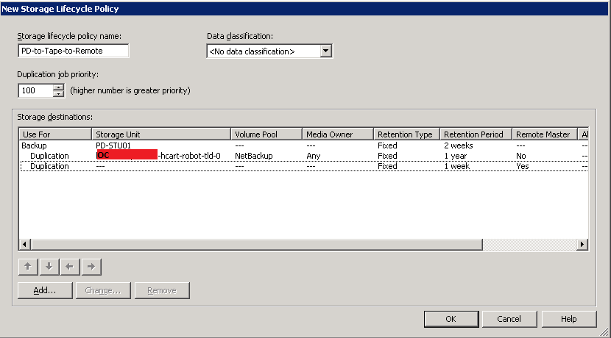
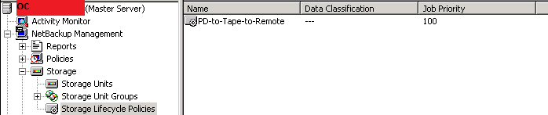
On your DR site master server, go to “NetBackup Management” -> “Storage” -> “Storage Lifecycle Policies” -> New
Keep in mind, it’s required to use the same SLP name as it is on OC site master server.
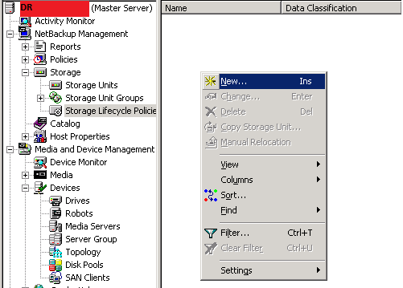
Click “Add” and choose “Import” for “Use for”, then choose “Remote Retention(specified in the source SLP)” as the “Retention Type” and choose your DR site Puredisk Storage Unit.
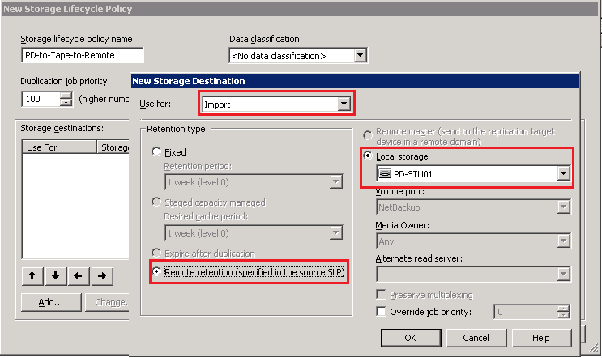
If you have other storage units, you can add them as well. In this example a tape device is added. Then using the right arrow, make this a copy of the first.
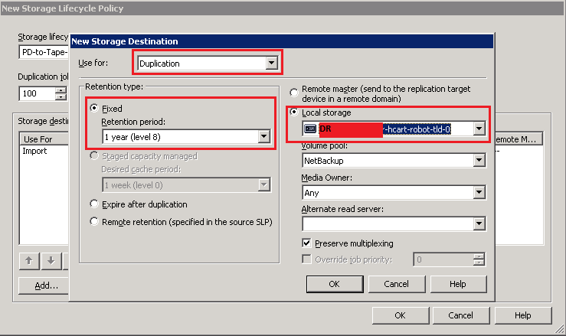
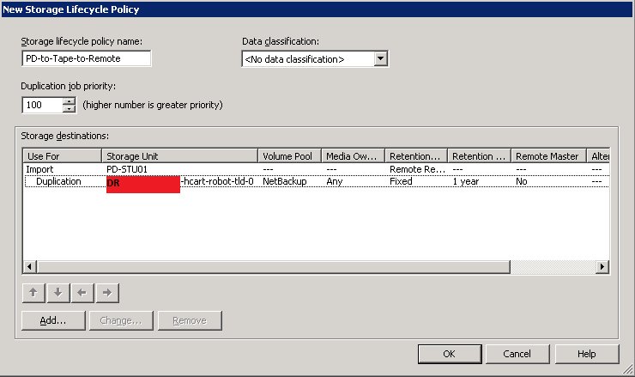
Now, use this SLP on your policies which you want the backups be replicated to your DR site.
How this configuration is going to run?
1. The backup will be taken to your OC Puredisk Pool
2. Then it will be copied to your tape device
3. At the same time, it will be replicated to your DR site, see below:
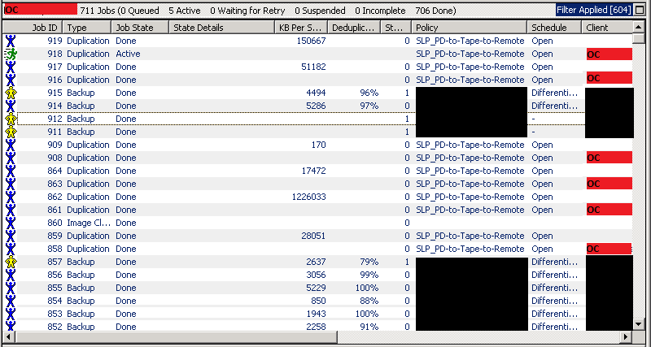
When the replication is complete, it will be directly imported on your DR site, see below:
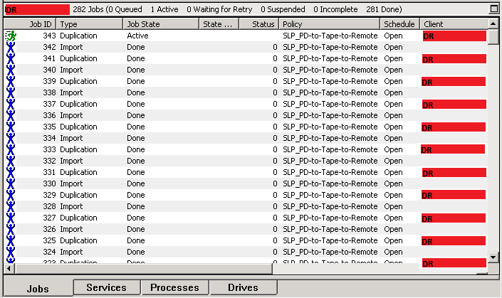
As a last action the imported backups will be duplicated to your tape in your DR center.

