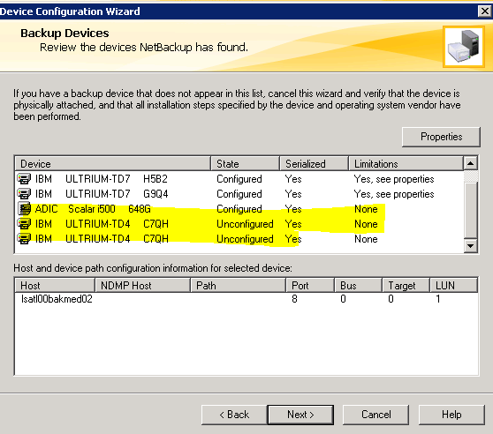

Why does it try to use an existing robot?
