Output of nbcertcmd on Master server:

Failure message following a standard client installation attempt:

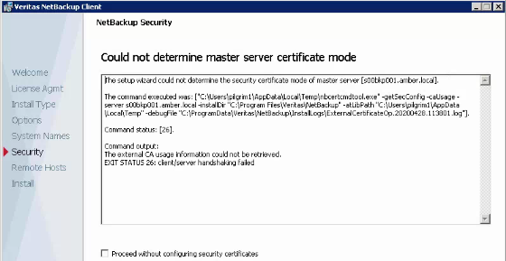

Files produced by installation attempt:
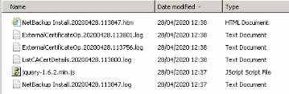

Current status of clients (note I have successfully updated a number of clients which do not reside behind a firewall):
